SOROKA – 17E

DIGITAL VOICE RECORDER

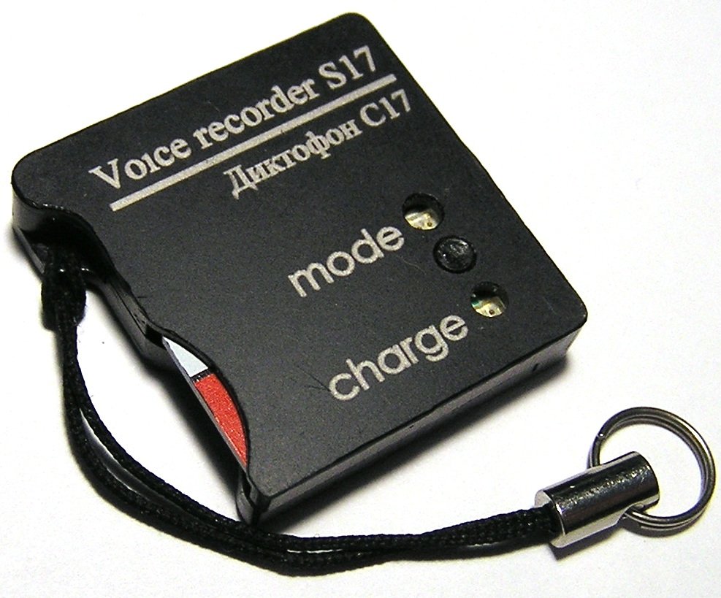

Operational Manual

CONTENTS
1 Product specification and description of its operation 4
1.1 Purpose of the voice recorder. 4
1.2 Main technical characteristics of the Recorder 4
1.3 Light indication of operation modes and battery charging modes. 5
1.4 Design and operation of the voice recorder. 7
2 Voice recorder usage 8
2.1 Operating limitations. 8
2.2 Preparation of voice recorder for usage. 8
2.3 Rechargeable battery charging 8
2.4 Setting voice recorder parameters. 9
2.5 Usage of the voice recorder. 9
2.6 Creating a configuration file. 9
2.7 Verification of files digital signatures. 12
2.8 External microphone connection. 14
3 system of voice recorder labels 15
4 Logger 15
5 Current repair of the voice recorder 17
5.1 General instructions 17
5.2 Typical faults 17
6 Storage and transportation 18
7 Manufacturer's warranty 18

The operation manual contains data on technical characteristics, the device and the principles of work, rules of storage, instructions on operation and maintenance, necessary for the correct operation and full use of technical capabilities of a SOROKA-17Е Recorder.

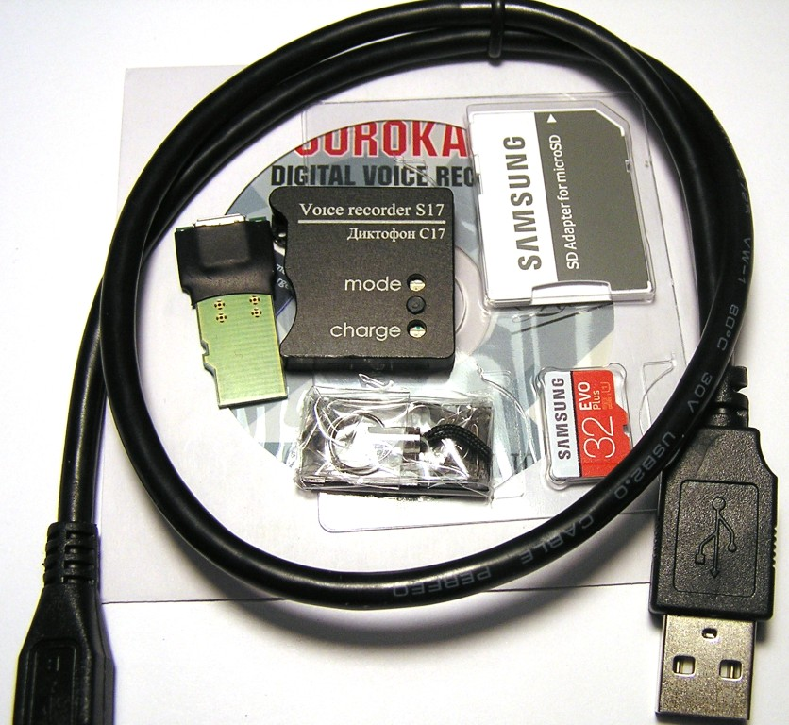
Fig. 1. Delivery set of voice recorder Soroka-17E.

Table 1. List of items supplied.
Name | The number | Option
Name | The number | 17E
1. Voice recorder «Soroka-17» | 1 | +
2. Memory card microSDHC | 1 | 32GB
3. The adapter for battery charging | 1 | +
4. Passport | 1 | +
5. USB cable to charge the recorder | 1 | +
6. CD with software and user manual | 1 | +
7. Packaging | 1 | +
8. CardReader | 1 | +

Product specification and description of its operation

Purpose of the voice recorder.
The voice recorder Soroka-17E is designed to record audio with the built-in digital MEMS microphone in mono mode to the micro SD memory card or micro SDHC Class4 or higher.

Basic specifications of the voice recorder are listed in Table 2.
Table 2. Specifications of the voice recorder SOROKA- 17E.
№ | Parameter |  | Description
1 | Dimensions |  | 26,5x26,8x5,3
2 | Operating temperature range |  | -20° C to +40° C
3 | Recording file format |  | «.WAV»
4 | Type of memory and filing system |  | Removable memory cards micro SD, micro SDHC; FAT32 filing system
5 | Interface with PC |  | via micro SD card
6 | Charger type |  | Cable USB – micro USB
7 | Discretization of sound frequency |  | 8 kHz, 16 kHz, 24 kHz, 32 kHz
8 | Resolution |  | 8 bit(u-law), 16 bit, 20 bit.
9 | Microphone Sensitivity |  | -26 dBFS at 94 dB SPL (8-9 meters)
10 | Non-Linear Distortion Ratio |  | less than 3%
11 | Frequency range as per level - 3 dB | Sample rate
11 | Frequency range as per level - 3 dB | 8 kHz | 3 Hz – 3.384 kHz
11 | Frequency range as per level - 3 dB | 16 kHz | 3 Hz – 6.768 kHz
11 | Frequency range as per level - 3 dB | 24 kHz | 3 Hz – 10.152 kHz
11 | Frequency range as per level - 3 dB | 32 kHz | 3 Hz – 13.536 kHz
12 | Duration of work, when the resolution is 16-bit with u-law compression | Sample rate | Typical operating time* (hours) | At least ** (hours)
12 |  | 8 kHz | 65 | 39
12 |  | 16 kHz | 46 | 27
12 |  | 24 kHz | 33 | 20
12 |  | 32 kHz | 27 | 16
13 | Duration of work, when the resolution is 16-bit without compression | Sample rate | Typical operating time* (hours) | At least ** (hours)
13 |  | 8 kHz | 56 | 33
13 |  | 16 kHz | 34 | 20
13 |  | 24 kHz | 27 | 16
13 |  | 32 kHz | 21 | 12
14 | Duration of work, when the resolution is 20-bit. | Discretization frequency | Typical operating time* (hours) | At least ** (hours)
14 | Duration of work, when the resolution is 20-bit. | 8 kHz | 42 | 25
14 | Duration of work, when the resolution is 20-bit. | 16 kHz | 26 | 15
14 | Duration of work, when the resolution is 20-bit. | 24 kHz | 18 | 11
14 | Duration of work, when the resolution is 20-bit. | 32 kHz | 13 | 8
15 | Suppression outside the band of operating frequency range while octave tuning |  | at least 60 dB
16 | Average life |  | for at least 2 years
17 | Average storage time |  | not less than 2 years, with the implementation of discharge / charge cycle every three months
18 | Battery charge time |  | up to 4 hours
19 | Function of real-time clock |  | Yes
20 | Function of work as an alarm clock |  | yes (up to 10 alarms or daily cyclic alarm clock)
21 | Function of files digital signature |  | Yes
22 | Voice operated switch (VOX) mode |  | Yes (three sensitivity levels and record tags at operation in VOX mode)
23 | Ability to manually control the recording level |  | Yes (only under 16-bit resolution and compression u-law ); from -12 dB to +18 dB in 6 dB.
24 | Automatic sound level adjusting |  | Yes (only under 16-bit resolution and compression u-law ); from -12 dB to +18 dB in 6 dB.
25 | Logger |  | Yes
26 | System of records tags in files |  | Tags at first and to the end of files; tags on pressing of the button; tags on operation of an akustopusk.
27 | Cyclic recording |  | Yes

* Typical operating time is set by the results of measuring the duration of voice recorders with memory cards microSDHC Samsung EVO + 32GB.
** Minimal operation time is determined by loss of battery capacity by 40% in the aging process, or at low temperatures.

Light indication of operation modes and battery charging modes.

Light indication of operation modes and emergency cases of the voice recorder is shown in table 3.

Table 3.Light indication of modes and emergencies.
Modes and emergency cases of the voice recorder | Status of Indicator "Mode"
a) Getting started (when the recorder is being switching on by the user) | 1. In normal recording mode, indicator turns green and stays so until the end of opening file process (duration of file opening depends on the file size and free memory capacity). After opening the file, indicator "Mode" repeatedly flashes green(internal microphone) / orange (external microphone), or if the accumulator discharged - red. A further indication is possible only by pressing a button.  2. If "dict.ini" file is tasked to operate by the alarm clocks, the indicator lights up green for 1 second and voice recorder enters standby mode by switching the alarm. A further indication is possible only by pressing a button.  3. If the recorder is set up to operate as voice operating switch, the indicator lights up for 1 second green, and then lights up for one second orange. A further indication is possible only by pressing a button.
b) Mono recording mode (after a brief pressing of control button) | 1. If the battery voltage is normal, the indicator repeatedly blinks green(internal microphone) / orange (external microphone).  2. If the battery is low, the LED blinks several times in red.
c) Recording mode with voice operated switch (VOX) (after a brief pressing of a button) | After detecting the audio signal of the preset level – similar to normal mode
d) Alarm clock record mode (after brief pressing of the button) | LED blinks slowly red and green colors, independently from the other recording modes and battery charge level.
e) Standby mode for alarm clocks (Short time after the brief pressing of the control button) | After brief pressing the button, there are triple-time alternate blinks red and green.
f) Emergency - incorrect filing system, the lack of a memory card or fault-of memory card | After switching the recorder on, indicator turns green, then - red, and then voice recorder turns off.
g) Status "No free space on the disc" | Indicator, after turning the voice recorder on, glows green for some time (depending on the size of the micro SD and size of file being created), then recorder turns off.

Charge modes light indication of the rechargeable battery is shown in Table 4.

Table 4. Charge modes of light indication of the voice recorder rechargeable battery
Charging modes | Indicator Status "Charge"
- The end of the charge of the rechargeable battery | Indicator "Charge" lights green
- Charge of the rechargeable battery | indicator "Charge" lights red

Design and operation of the voice recorder.
The appearance of the voice recorder Soroka-17E is shown in Figure 2.

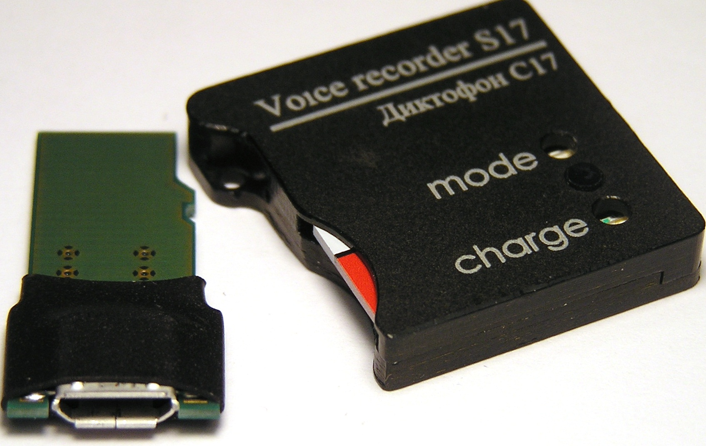
The adapter for connection of the charger
Мemory card
Operating mode indicator
Inclusion button
Battery charge indicator

Fig. 2. Appearance of voice recorder Soroka-17E

Voice recorder usage

Operating limitations.
To avoid the voice recorder failure, observe the following rules:

a) Rechargeable battery charging should be carried out only from USB port of PC and with USB adapter from the delivery set;

b) Protect voice recorder from mechanical shocks – severe bumps may lead to possible microphone destruction. If the voice recorder received mechanical damage during operation and this led to its failure, it is not covered by warranty.

c) Do not allow dust and moisture on the microphones, as it can lead to significant deterioration of the digital microphone performance.

Preparation of voice recorder for usage.

It is strongly advisable to read carefully this Manual before starting to use the voice recorder.

Before starting to use the voice recorder, it is necessary to carry out an external inspection for mechanical damage. On the surface, there should be no cracks, chips, dents. Metal parts should not have any traces of corrosion.

Before the work, it is necessary to configure the voice recorder parameters according to chapter 2.4 of this document.

Check the recording length of the voice Recorder in accordance with Table 2.

Check the microphone operation, make and listen to test recordings on your PC.

Rechargeable battery charging
Connect the charger to the voice recorder via the adapter from a set of delivery and then plug it in the s
If the battery is discharged, the indicator "Charge" will light up red. Once fully charged, the battery indicator "Charge" will turn green. Charging time of a fully discharged battery is approximately 4 hours.

Attention! If you want to keep recorder unused for more than a month, it is needed first to fully charge it.

Setting voice recorder parameters.
Insert the micro SD card into the card reader. Format the micro SD under the filing system FAT32.

Create a folder with any name on your computer.

Copy the dict.exe program from the supplied CD disk (or download it from our web-site) into the created folder.

Run dict.exe program and following chapter 2.6 of this document create a configuration file named dict.ini

Copy the created file dict.ini to the memory card.

Insert the memory card into the voice recorder and switch it on. The voice recorder will read configuration file and save it to the internal memory. After reading the settings from the file, voice recorder will automatically remove it and continue to work in a user-defined mode (indication as shown in Table 3).

Usage of the voice recorder.

Insert the formatted under FAT32 micro SD card into the voice recorder.

Turn the voice recorder on by pressing the control button for 2 seconds. After turning on, voice recorder enters the operating mode which has been set by the user at the last setting.
To display the voice recorder current status, briefly press the control button. The current state is determined according to the indications in the table. 3.
To switch the recorder off, press the control button and hold it down till the mode indicator stops flashing or goes out (indicator must either begin to turn solid green, or goes off). Moreover, if the operation has been set for the alarm clock, the operation of all alarms is canceled.
After switching the voice recorder off, remove the memory card and insert it into a card reader. To verify digital signatures, use the tab "Verifying files integrity" of the program dict.exe. Before using program, please, read paragraph. 2.7 of this document.
To listen to the recorded files, use any player that supports "WAV" format (recommended is SOUND FORGE version 6.0 and later).

Creating a configuration file.

Run dict.exe program and in the opened window select tab "Setting up the voice recorder", as shown in Fig. 3. This tab is used to create / read files dict.ini and it contains the following parameters and options:

a) Enable\disable voice activation (VOX). When this mode is active, recorder starts recording once the audio level of a sound signal exceeds a predetermined threshold. If the audio level is below a predetermined threshold for 15 seconds, then the voice recorder stops recording and enters the standby mode of the acoustic signal, without closing of the current file. Sound recording fragments are consistently registered in the current file (up to 70 fragments in one file). For each voice operated switching the tag indicating date and time of voice operated activation (the beginning of a fragment) will be created in the file (see paragraph 3). Record fragments of voice operated switch will be separated in the file from each other with either silence, or beep (item 2.6 (b)).

b) Beep between fragments. After switching the voice activated mode on, the user can choose a way of fragments separation in the current file. In case of setting a tag "Beep between fragments", all sound recording fragments in the current file will be divided by beeps, or, otherwise by silence. Use of beeps between fragments allows the user to define aurally the beginning of a new fragment when listening files.

c) Sensitivity of voice recording switch. The user can adjust a threshold of voice operated switch by setting of value in the “Sensitivity of VOX” window. The higher the chosen sensitivity, the quieter sounds will be recognized by recorder. The recommended sensitivity value is "average". Under sound resolution of 20 bits sensitivity of VOX is a fixed value and is not adjustable.

d) To switch on/off the automatic adjustment of record level. After activation of this function, loud sounds will be weakened, and quiet, on the contrary – amplified. That will allow aligning the sound level automatically. This function isn't available (is not required) at sound resolution of 20 bits.

e) To set the fixed strengthening of record level. If the user or the program have turned sound level automatic adjustment off, then it is necessary to set record level amplification from the available row. The recommended values are 0 dB, +6 dB and +12 dB. This function isn't available (is not required) at resolution of a sound of 20 bits.

f) To set the written-down files size. In this window the user has to choose the files size recorded to the memory card from the following row: 50 MB, 100 MB, 250 MB, 500 MB, 1000 MB, 1800 MB. The less the files size, the less time is required for their opening, but the more short-term pauses are in a sound recording when opening the new file.

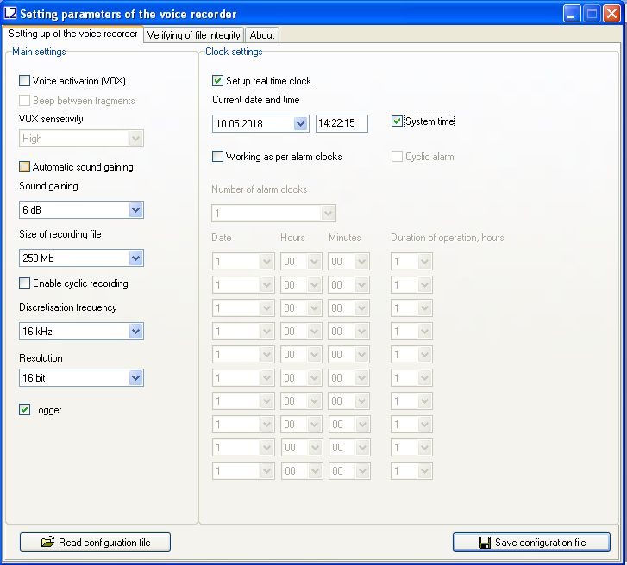
j
l
k
a
b
c
d
e
f
g
h
i
m
n

Fig. 3. Tab "Setting the recorder" in dict.exe program window.

g) Choice of sampling frequency. Possible values are 8 kHz, 16 kHz, 24 or 32 kHz. The higher sound sampling frequency value, the higher quality of the sound written-down, however the time of autonomous work of a voice recorder is less.

h) Sound resolution. The voice recorder can record in three formats: 16 bits under u-law compression, 16 bits without compression, 20 bits without compression. Use of u-law compression allows to significantly increase record duration and by two/tree times decrease memory consumption on the microSD card in comparison to the record modes in a format 16/20 bits without compression.

i) Switching on/off logger. When logger is switched on, all main events will be saved into internal memory of voice recorder with their time and date. There is also voice recorder production data stored (Identification number and number of the internal software). At normal switching off of the voice recorder, the last 48 events will be copied from the internal memory onto microSD in the INF_REG.TXT file. For more detailed information about the logger see paragraph 4.

j) To set the current time and date. To use the current system time, put a tick to "System time". To manually change date and time in file system of a voice recorder, remove tick on "System time" and put a tick "Adjust real time clock".

k) Switching on/off work on timers. To activate recording at certain moments and for certain time period, it is necessary to set a tick to "Work on alarm clocks". Operation is possible either in the mode of "A cyclic alarm clock" or by individually adjusted alarm clocks. In the mode of "A cyclic alarm clock" the voice recorder makes records daily in the adjusted time interval. During the work by individual alarm clocks it is necessary to set quantity of alarm clocks in the “Quantity of alarm clocks” window, depending on the necessary number of record activations. For initialization of each alarm clock set date (day of month) and activation time, as well as record duration after which voice recorder will switch off and expect activation of the following alarm clock. Alarm clocks work in strict sequence from the first to the tenth. The voice recorder will be switched off automatically after the last alarm clock activation.

l) Writing down the configuration file. After adjustment of the required configuration press the “Save configuration file” button. The program will create new or will rewrite already available file of the dict.ini settings to the specified directory. Copy the created dict.ini file to the microSD card and switch voice recorder on.

m) Reading the configuration file. If it is necessary to read contents of earlier created settings file, then press the “Read configuration file” button and choose a directory for reading of the dict.ini file.

n) Switching on/off cyclic recording. This feature could be activated if it is needed to continue recording when the memory card is full. Information will be recorded over the oldest one on the memory card.

Verification of files digital signatures.
Run dict.exe program and select the "Verifying of file integrity" tab, as shown in Fig. 4. This tab is designed to verify digital signatures of the desired file.

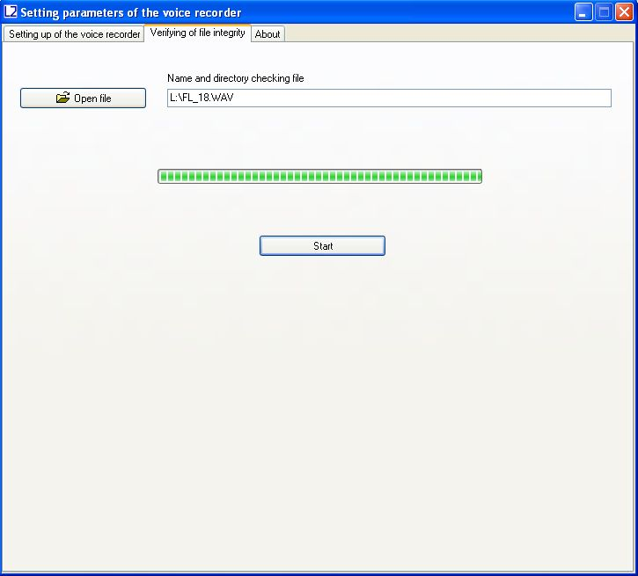
a
b
c

Fig. 4. Example of digital signature verifying.

In the tab "Verifying of file integrity " there are the following controls:
- Open the file. Click "Open File" and select the desired directory and file. After selecting of the desired file, the program will perform checking of its digital signature.
- Indicator of the progress digital signature calculation.
- Button "Start" / "Stop". File digital signature checking runs by pressing the "Start" button. By pressing “Stop” button the checking process stops.

At the end of the file checking, the program will show the message "The digital signature is valid", if the integrity is not violated. If the file contains errors, the program displays the message "The digital signature is not valid!".
Also, for each file, the serial number of the voice recorder is shown (Fig. 5).

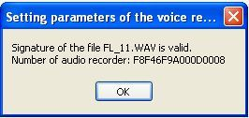а)
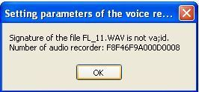b)
Fig. 5. Output of files test results: a) a digital signature of the file is valid; b) Digital signature of the file is not valid.

After verifying the digital signature of the selected file dict.exe program generates a report with information available in the labels file. The report contains information about the number of tags in file to be scanned, their names and their corresponding samples.
This file has the same name as the file which is checked, but with the extension «.txt» (for example, if the original file is named «FL_8.WAV», the file with information about the labels will have the name «FL_8.TXT»). The generated file with information on labels is automatically stored in the directory of the originally scanned file or directory in which to save the file (see. 2.7 (b)). File with information on labels can be useful when listening to audio in programs that do not have label recognition.

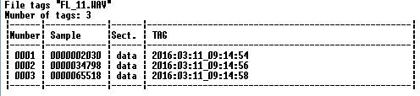
Fig. 6. The file structure with information about the tags, formed by dict.exe programm.

External microphone connection.

The external microphone is connected via USB connector of the recorder. The external microphone connection is checked when the recorder is turned on. The recorder indicates the use of an external microphone with orange (simultaneous green and red) blinking LEDs.

System of voice recorder labels
Recorder Soroka-17E supports automatic layout of files. Tags system makes files analysis more convenient and allows it to avoid wasting time of files creation and modification when copying. The labels in the recorded files are placed in the following cases:

1) At the beginning and at the end of each file.
2) When you press the control button of voice recorder for the purpose of marking the desired moment.
3) In the voice activation mode, every time when it detects an audio signal (actuation of the voice activation mode).

Analysis of the tags may be formed, for example, using Sound Forge version 6.0 or higher, or using software supplied dict.exe (Section 2.7).

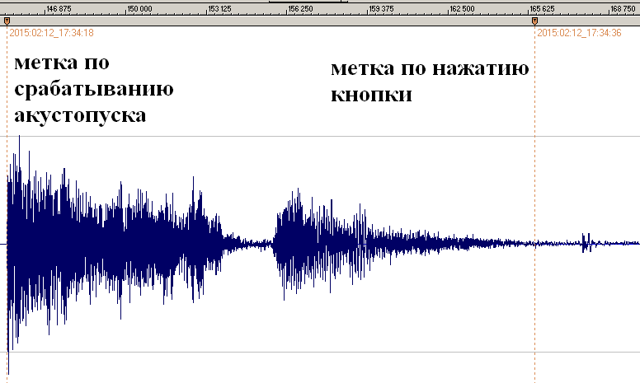
Tag on VOX initialization
Tag on pressing the button

Fig. 7. Example of automatic tags recognition by the Sound Forge program in audio files of voice recorder. The name of each label corresponds to the date and time of its creation.

Logger
Logger is designed to register history of recorder’s operation and emergencies to the non-volatile memory.

In addition, logger contains manufacturing data (recorder identification number and firmware number)

Logger stores from 32 to 48 latest events, as well as their time and date.

If the logger is turned on (see. 2.6 (i)) and voice recorder is switched off (except emergency reset) logger is recorded to micro SD into the file INF_REG.TXT.

It is not recommended to use the logger continuously since this reduces nonvolatile memory resource of the voice recorder (it only affects work of the logger itself).

Brief description of the recorded events and the logger structure is given in Table 5.

Table 5. Description of logger tags and events.
Shorthand | Description
DEVICE_NUMBER | Voice recorder identification number
POWER_RESET | Reset by power failure
PIN_76_RESET | Processor hardware reset
PMMSWBOR | For official purposes
WAKE_UP_FROM_LPX.5 | For official purposes
SECURITY_VIOLATION | For official purposes
SVSL | For official purposes
SVSH | For official purposes
SVML_OVP | For official purposes
SVMH_OVP | For official purposes
PMMSWPOR | For official purposes
WATCH_DOG_TIME_OUT | Looping / stop of the processor’s program due to memory card or software failure
WDT_PSWRD_VIOLATION | For official purposes
FLASH_PSWRD_VIOL | For official purposes
PLL_UNLOCK | For official purposes
PERF_AREA_FETCH | For official purposes
PMM_PSWRD_RESET | Forced software reset (occurs when overwriting voice recorder microprocessor program). Is called forcibly.
LOW_VOLTAGE_TURN_OFF | Low Battery - The recorder is turned off
BUTTON_TURN_OFF | Voice Recorder is turned off by pressing
BUTTON_TURN_ON | Turning the voice recorder on by pressing
SD_MEMORY_IS_OVER | No free space on the microSD - the voice recorder is switched off
ALARM_TURN_OFF | Voice recorder is turned off by timer
ALARM_TURN_ON | Voice recorder is turned on by timer
SD_READ_TIMEOUT | Micro SD does not respond to a command to read data
SD_WRITE_FAILURE | Command to record data do not pass to micro SD
NO_SD_BLKWR_RESPONSE | There is no confirmation from mcroSD to the recording data block
PROGRAM_BOR_RESET | Complete reset of the voice recorder. Called forcibly, if the voice recorder has not detected a microSD memory card or if the memory card of filing system contains errors.
SNMI_INTERRUPT | Microprocessor system failure (it is necessary to save the file INF_REG.TXT)
FLASH_ACCESS_ERROR | Error of the program (it is necessary to save the file INF_REG.TXT)
OSCILATOR_FAULT | Hardware failure of the oscillator
NMIFG_INTERRUPT | Microprocessor system failure (it is necessary to save the file INF_REG.TXT)
EMPTY_CELL | Empty cell
UNDEFINED_ERROR | Unspecified error or reset
DICT_SOFTWARE_NUMBER | Number of internal recorder software

Current repair of the voice recorder

General instructions
If any defect of the voice recorder is detected, repair works are needed. Current repair of the voice recorder should be made at the factory or in the workshop.

Attention!!! Unauthorized opening of the voice recorder leads to the withdrawing of the warranty from the voice recorder.

Typical faults
Typical faults of the voice recorder, which may be eliminated by the user, are shown in Table 6.

Table 6. Typical faults of the voice recorder, and their solutions.
Faults | Methods of correction
The voice recorder doesn’t switch on | Charge the storage battery
Recorded audio files are not readable or contain errors | Replace the memory card. If this does not work, then contact the service center.

Storage and transportation

The voice recorder should be kept in its original packaging in heated storage rooms at a temperature ranging from +5 to +25 ˚C with relative humidity less than 80% (at +20 ˚C). The environment must be free from pairs of acids, alkalis and other aggressive impurities.

The Voice Recorder in special packaging may be transported in closed vehicle (rail cars, containers, cars, water [sea or river] transport), as well as in sealed cockpits of planes and helicopters.

Attention! If you want to keep recorder unused for more than a month, it is needed first fully charge it.

Avoid storing the voice recorder in premises with air temperature over 25 ˚C.

Manufacturer's warranty

The manufacturer guarantees the accordance of the voice recorders to the technical requirements, providing that the customer observe instructions for operating conditions, transportation and storage, set up by this manual.

The warranty period is 12 months within the warranty period of storage.

The warranty period of storage is 18 months from the date of production, if the charge / discharge cycles of the battery are held every 3 months.

The warranty period is extended for the period of warranty repairs, if any.

In case of defects, discovered in the voice recorder due to the manufacturer’s fault within the warranty period, troubleshooting and replacing (if needed) of the voice recorder and its components are made at the manufacturer's expense.

